
RV COLLEGE OF ENGINEERING
Bengaluru-560 059

REPORT ON
EXPERIENTIAL LEARNING
ACY 2025-26
Computer Science
Second Sight – Assistance for Visually Impaired
Students Group
SL. No. | USN | Name | Prog.
1. | 1RV24CI089 | Rachit Mittal | CI
2. | 1RV24CI106 | Sambhav Badaya | CI
3. | 1RV24CY056 | Tanishq Gupta | CY
4. | 1RV24CY021 | Hardik Jain | CY

Project Evaluators
SL. No. | Name of the Evaluators (Enter the Names in Capitals)

Dr. Pavithra H | Dr. Shanta Rangaswamy
Name of the Faculty Mentor | Name of the Cluster Head

1. Introduction
Visual impairment significantly impacts an individual’s ability to navigate physical environments, access written information, and perform daily financial transactions independently. While assistive tools such as white canes and guide dogs offer basic mobility support, they lack contextual awareness and cannot provide real-time information about surrounding objects, text, or digital transactions.
With the advancement of smartphone hardware and software ecosystems, mobile devices have become powerful platforms capable of real-time computer vision, on-device machine learning, and secure biometric authentication. Modern smartphones are equipped with high-resolution cameras, depth sensing capabilities, and optimized AI frameworks, enabling them to function as intelligent assistive devices.
This project presents Second Sight, a multi-component assistive system consisting of an iOS application, a Node.js backend with persistent storage, and a React dashboard. The system assists visually impaired users through obstacle awareness, meaningful text reading, Indian currency recognition, the AI-powered Describe feature, and secure QR-based transactions with Face ID authorization. Describe sends the current camera image through the backend to MiniCPM-V 4.6 in LM Studio and speaks the returned scene summary. On-device perception uses ARKit, Vision, Core ML, and TensorFlow Lite.

2. Problem Definition
2.1 Problem Statement
Visually impaired individuals face multiple interconnected challenges in daily life, including:
- Difficulty in detecting and avoiding dynamic obstacles such as people, furniture, and vehicles.
- Inability to read printed text on signs, labels, or documents without assistance.
- Difficulty in identifying currency denominations during financial transactions.
- Dependence on third-party assistance for digital payments, increasing the risk of fraud.
- Lack of secure, accessible interfaces for authorizing financial transactions.
Existing assistive applications often focus on a single functionality, require continuous internet connectivity, or rely on external hardware. Additionally, most digital payment systems assume visual confirmation and manual input, making them unsuitable for visually impaired users.
The core problem addressed in this project is the absence of a single, integrated, secure, and accessible system that combines environmental awareness with trusted digital payment authorization for visually impaired individuals.

3. Objectives
3.1 Primary Objectives
3.1 Primary Objectives
- To design and develop an iOS-based assistive application using real-time computer vision.
- To enable obstacle detection and navigation assistance using on-device machine learning.
- To implement text recognition for reading printed content through audio feedback.
- To implement secure QR-based wallet transactions authorized exclusively using Face ID.
- To ensure reliable communication between the mobile application and backend wallet system.

3.2 Secondary Objectives
- To design gesture-based interaction suitable for visually impaired users.
- To integrate a backend wallet system with persistent transaction storage.
- To provide a React-based dashboard for monitoring wallet balance and transactions.
- To ensure strict mode exclusivity to avoid detection conflicts during QR payments.
- To maintain modular and scalable architecture for future enhancements

4. Methodology
4.1 Approach
The project follows a multidisciplinary methodology integrating mobile application development, computer vision, machine learning, backend development, and web technologies.
The iOS application continuously captures ARKit camera frames and routes them according to the active mode. YOLO obstacle detection runs through Core ML and Vision. Text recognition uses accurate Vision OCR with confidence, geometry, keyboard-pattern, fragmentation, and lexical filtering. Currency recognition combines OCR with a trained six-class TensorFlow Lite classifier. The Describe feature compresses the current camera frame, sends it through /api/perception/analyze, and speaks the concise summary generated by MiniCPM-V 4.6 through the LM Studio backend connection.
A dedicated QR Scan Service detects QR codes using Vision barcode detection. Detected QR values are validated against an allowlist to ensure security. Upon successful QR validation, the user is prompted to enter an amount, which is confirmed using speech output. Face ID authentication is then triggered, and only upon successful biometric verification is the wallet transaction sent to the backend.
The backend processes wallet operations using REST APIs and stores data in MongoDB. The React frontend fetches this data periodically to display wallet balance and transaction history.

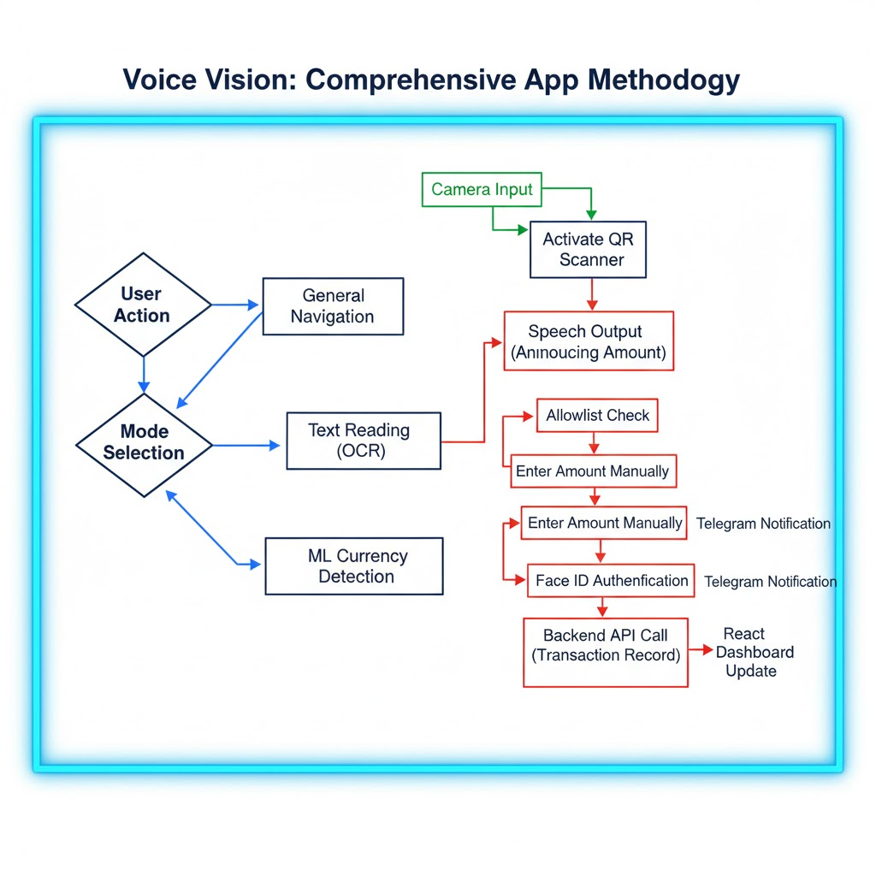
Methodology flowchart
5. Project Execution
5.1 Planning and Design
- Initial planning focused on identifying limitations of existing assistive and payment systems for visually impaired users. Key design goals included accessibility, security, performance, and modularity. Multiple design iterations were carried out to define gesture-based interactions, mode exclusivity rules, and backend communication flows.
- System architecture was designed to clearly separate concerns between camera handling, recognition pipelines, speech output, and network communication. Special emphasis was placed on ensuring that QR Pay Mode remains exclusive to prevent performance degradation and accidental detections.

5.2 Implementation
- 5.2.1 iOS Application Development
The iOS application was developed using SwiftUI and ARKit. Vision and Core ML handle obstacle detection, Vision performs filtered OCR and QR scanning, and TensorFlow Lite runs the Indian currency classifier. A centralized view coordinates mode switching, gesture handling, speech prompts, MiniCPM scene-description requests, QR scanning, amount entry, and Face ID authentication.

5.2.2 AI-Powered Describe Feature
Describe extends Second Sight beyond fixed-class detection by explaining the complete visible scene. MiniCPMService captures the current ARKit frame, converts it to a compressed JPEG, and sends it with a concise accessibility-focused prompt to the backend perception endpoint. The backend forwards the multimodal request to the OpenAI-compatible LM Studio server running MiniCPM-V 4.6. The returned summary is spoken using AVSpeechSynthesizer. Request cooldowns and duplicate-summary suppression prevent repetitive output. This feature requires the Mac backend and LM Studio to be reachable over the local network; the other on-device recognition features remain available independently.

5.2.3 Backend Development
The backend was implemented using Node.js and Express. REST APIs were created for wallet operations such as balance retrieval, adding funds, and sending money. MongoDB was used for persistent storage of wallet data and transactions.

5.2.4 Frontend Dashboard Development
The React dashboard was developed to provide a visual interface for monitoring wallet activity. It displays wallet balance, transaction history, and supports manual fund addition and transfers. Polling was implemented to refresh data every two seconds.

5.2.5 Testing
Testing covered model accuracy, empty-scene currency rejection, meaningful-text filtering, keyboard OCR rejection, mode switching, QR validation, biometric authorization, backend endpoints, and dashboard behavior. The old and new currency models were evaluated on the same 293-image held-out set, and exact train-test duplicate checking found no overlap.

6. Tools and Techniques Used
6.1 Tools
Tool | Purpose
Swift and SwiftUI | iOS application and accessible interface
ARKit | Continuous camera capture and spatial session
Vision and Core ML | OCR, QR scanning, and YOLO11n obstacle detection
TensorFlow Lite | MobileNetV2 Indian currency classification
AVSpeechSynthesizer | Spoken prompts and recognized-content output
LM Studio / MiniCPM-V 4.6 | Optional local vision-language scene description
Node.js, MongoDB, React | Wallet backend, persistence, and dashboard
Xcode and devicectl | iPhone builds, signing, installation, and testing

6.2 Techniques
- On-device machine learning for real-time perception
- Gesture-based user interaction design
- Biometric authentication using Face ID
- RESTful API design
- Polling-based frontend data synchronization

7.Results and discussion

7.1 Final Results
- The developed system was successfully implemented and tested across all its major components, including the iOS mobile application, backend wallet services, and the web-based dashboard. The results demonstrate that the project meets its intended objectives of providing assistive navigation, text and currency recognition, and secure digital payment functionality for visually impaired users.
- The iOS application reliably captured and processed live camera frames. Obstacle detection provided navigation-oriented audio feedback. Text recognition now uses accurate OCR and semantic filtering to reject keyboard rows, fragmented characters, and unrecognizable jargon before prompting; a second validation occurs when the user taps to read. This prevents irrelevant sequences such as Q-W-E-R-T-Y from being spoken while preserving signs, prices, numbers, and common abbreviations. The Describe feature successfully routed image prompts to the configured MiniCPM-V 4.6 endpoint and returned scene summaries for spoken delivery when the Mac services were available.
- Currency recognition was evaluated on 293 held-out images across ₹10, ₹20, ₹50, ₹100, ₹200, and ₹500. The removed Core ML model achieved 16.0% accuracy (47/293), while the trained TensorFlow Lite model achieved 91.1% (267/293). The deployed pipeline additionally requires note-shape evidence, ≥0.85 confidence, a ≥0.25 top-two margin, and two consecutive matching frames. The model does not support ₹2000 because that class was absent from its dataset. QR Pay Mode continued to enforce allowlisting, mode exclusivity, and Face ID authorization.
- On the backend side, wallet operations such as balance updates, fund addition, and money transfer were processed correctly and stored persistently in the database. Transaction records were accurately reflected on the React-based dashboard, which refreshed data in near real time. Overall system testing confirmed stable performance, secure transaction handling, and seamless coordination between the mobile application, backend services, and frontend dashboard.

7.2 Discussion
All primary objectives of the project were successfully achieved. The integration of biometric authentication added a strong security layer, preventing unauthorized transactions. The modular design ensured smooth coordination between the mobile application, backend, and frontend dashboard. Performance remained stable due to controlled activation of recognition pipelines

7.3 Currency Model Comparison and Implemented Improvements
Both currency models were evaluated using identical preprocessing on the same held-out set of 293 images. The set contained six denominations and no exact duplicates of training images. The comparison therefore measures suitability for the current six-class deployment; it does not evaluate ₹2000 or every possible real-world background.
Criterion | Old model | New model
Runtime and input | Core ML, 299 × 299 BGR | TensorFlow Lite, 224 × 224 RGB float32
Classes | 7, including ₹2000 | 6: ₹10 to ₹500; no ₹2000
Correct predictions | 47 of 293 | 267 of 293
Overall accuracy | 16.0% | 91.1%
New-model accuracy by denomination was ₹10: 86.8%, ₹20: 93.3%, ₹50: 97.7%, ₹100: 79.1%, ₹200: 96.1%, and ₹500: 92.9%. The old model scored 1.9%, 3.3%, 4.5%, 2.3%, 0.0%, and 97.6%, respectively.
- Replaced IndianCurrency.mlmodel with the trained IndianCurrency.tflite model and integrated a pinned TensorFlow Lite Swift runtime.
- Added banknote-shape detection, brightness gating, 0.85 confidence, a 0.25 top-two probability margin, and two consecutive matching frames before announcing currency.
- Corrected consensus logic so the first prediction is no longer published immediately; empty scenes clear pending results.
- Upgraded Vision OCR to accurate mode with language correction and 0.55 confidence filtering.
- Added keyboard-row, fragmented-character, dictionary, signage, number, and acronym checks at recognition time and again before speech.
- Configured optional MiniCPM-V 4.6 scene description through LM Studio and the backend; this feature requires the Mac service to be reachable, unlike on-device currency inference.

8.Prototype (Hardware/Software)

8.1 Prototype Description
The proposed prototype is a software-centric assistive system primarily implemented as an iOS mobile application, supported by a backend wallet server and a web-based dashboard. Unlike traditional assistive devices that require additional hardware, this system relies entirely on the capabilities of a modern smartphone, making it cost-effective and easily deployable.
The iOS application is the core Second Sight prototype and uses the device camera for real-time perception. It integrates Core ML obstacle detection, semantically filtered Vision OCR, TensorFlow Lite currency recognition, QR scanning, and the named Describe feature. Describe uses backend-proxied MiniCPM-V 4.6 to turn the current image into a spoken semantic scene summary. Controlled modes and cooldowns limit workload conflicts and unnecessary audio output.
The backend prototype consists of a Node.js and Express-based wallet system connected to a MongoDB database. This backend manages wallet balance, transaction history, and transaction validation. Additionally, the backend supports Telegram-based notifications to inform users or administrators about wallet activities.
The frontend prototype is a React-based dashboard that visually represents wallet data, including balance and transaction history. It provides an administrative and monitoring interface that complements the mobile application.

8.2 Development Process
The development of the prototype followed an incremental and modular approach, ensuring that each system component could be tested independently before full integration.
Development began with ARKit camera integration, Core ML obstacle detection, and Vision OCR. Currency recognition was subsequently migrated from the original Core ML classifier to a trained MobileNetV2-based TensorFlow Lite model. The pipeline was then hardened with note-presence detection, confidence-margin rejection, and true consecutive-frame consensus. OCR was upgraded with language correction and semantic filtering, and MiniCPM-V 4.6 was configured through LM Studio for optional scene descriptions.
Subsequently, the QR Pay Mode was designed and implemented as a separate and exclusive operational mode. Special attention was given to security and usability, leading to the integration of Face ID-based biometric authentication. The development process ensured that no financial transaction could occur without explicit biometric approval from the user.
Parallel to mobile development, the backend wallet system was implemented using Node.js and Express. REST APIs were designed for wallet balance retrieval, adding funds, and sending money. MongoDB was chosen for persistent data storage due to its flexibility and scalability.
Finally, the React dashboard was developed to visualize backend data. Polling-based data fetching was implemented to ensure near real-time updates of wallet balance and transactions. Throughout development, emphasis was placed on clean architecture, separation of concerns, and maintainability.

8.3 Testing and Validation
Extensive testing and validation were carried out to ensure the reliability, accuracy, security, and overall stability of the proposed assistive system. Testing was performed at multiple levels, including unit testing of individual modules, integration testing between system components, and end-to-end functional testing under realistic usage conditions.
The iOS app was tested for camera acquisition, mode switching, device builds, and real-time processing. Currency tests included the shared 293-image benchmark plus bare-table scenarios to verify that empty scenes clear detections. Text tests included keyboards and fragmented labels to verify that meaningless sequences are rejected before speech. QR tests covered allowlisted and untrusted payloads, amount confirmation, and successful, cancelled, and failed Face ID flows. Backend and dashboard validation covered balance updates, transaction recording, error handling, and polling.
The QR scanning functionality was validated using multiple QR codes, including allowed and non-allowed values. Only allowlisted QR codes triggered the payment workflow, confirming correct implementation of security constraints. Amount entry and speech confirmation were tested to ensure accurate user feedback. Face ID authentication was tested under different scenarios, including successful authentication, user cancellation, and authentication failure. In all cases, the system correctly prevented unauthorized transactions when biometric verification was unsuccessful.
Backend APIs were tested using manual requests and automated calls to verify wallet balance updates, transaction recording, and error handling. Edge cases such as insufficient balance and invalid inputs were also tested. The React dashboard was validated for correct rendering of wallet balance and transaction history, and polling behavior was tested to ensure timely data updates. Overall, testing and validation confirmed that the system operates reliably, securely, and as intended under normal operating conditions.

9. Conclusion

9.1 Summary
The objective of this project was to design and develop an intelligent, secure, and accessible assistive system for visually impaired users by leveraging modern mobile technologies. The project successfully integrates real-time computer vision, machine learning, biometric authentication, and full-stack web development into a single cohesive solution.
The Second Sight iOS application provides obstacle awareness, filtered text reading, six-denomination currency recognition, the AI-powered Describe feature, and secure QR wallet payments. Describe sends a live camera image through the backend to MiniCPM-V 4.6 in LM Studio and speaks the returned scene summary. Core ML remains responsible for on-device obstacle detection, while currency inference uses TensorFlow Lite and OCR uses Apple Vision. The currency model comparison showed 91.1% accuracy for the deployed model versus 16.0% for the removed model on the common held-out set. Face ID remains mandatory for QR payments.
The backend wallet system effectively manages balance and transaction history using a structured database, while the React-based dashboard offers transparent monitoring and control of wallet activities. Strict mode exclusivity and well-defined workflows ensure system stability and usability even under real-time constraints.
Overall, the project successfully meets all its primary and secondary objectives. It demonstrates how emerging technologies such as augmented reality, artificial intelligence, and biometric authentication can be combined to create inclusive and socially impactful solutions. The system has strong potential for real-world deployment with further enhancements and scalability improvements

9.2 Personal Reflection
Rachit Mittal: I was primarily responsible for developing the iOS application and implementing the currency recognition model. I worked extensively on camera integration, real-time detection pipelines, and performance optimization. This project helped me gain strong practical experience in mobile application development and on-device machine learning.
Sambhav Badaya: My main contribution was the design and development of the virtual wallet system and backend APIs. I worked on handling wallet balance, transaction history, and secure fund transfers. This experience improved my understanding of backend architecture, database management, and API integration
Tanishq Gupta: I contributed to the development of the web-based dashboard and assisted in integrating the frontend with the backend services. I worked on displaying wallet balance and transaction history in real time. This role helped me strengthen my skills in frontend development and full-stack coordination.
Hardik Jain: I was involved in testing, validation, and documentation of the complete system. I assisted in identifying integration issues and verifying correct system behaviour. This experience enhanced my understanding of software testing practices and technical documentation

10.Visuals:
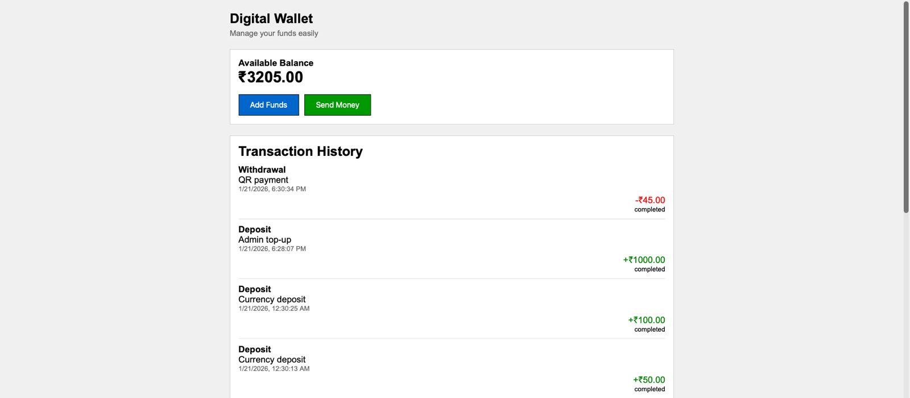 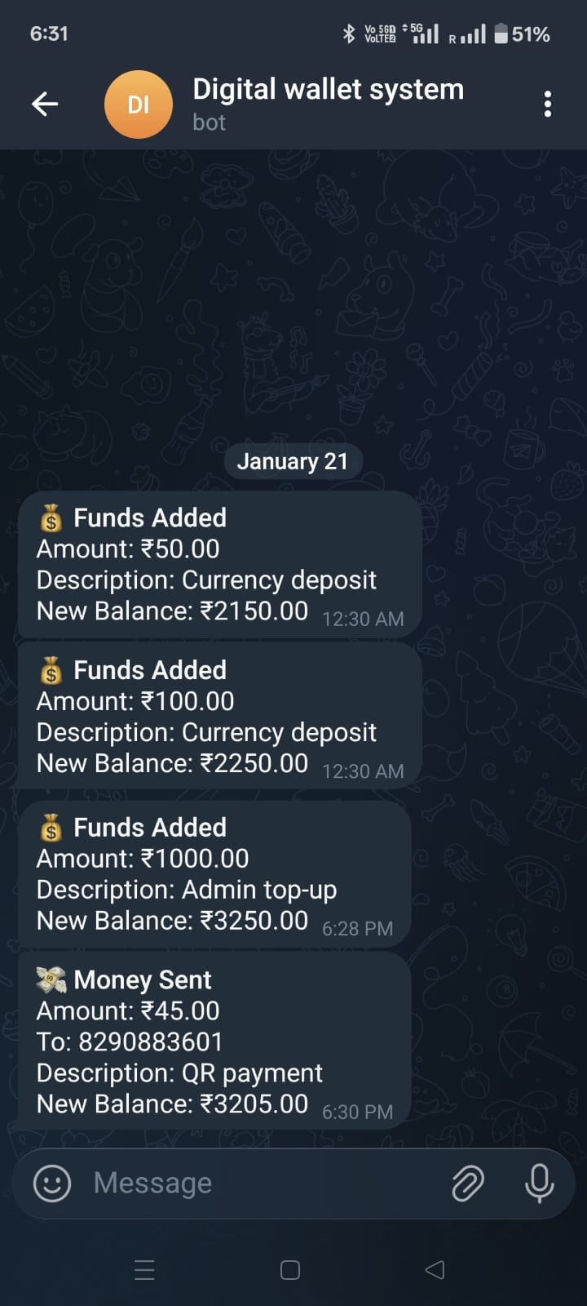 Digital Wallet System Telegram Notification for payment

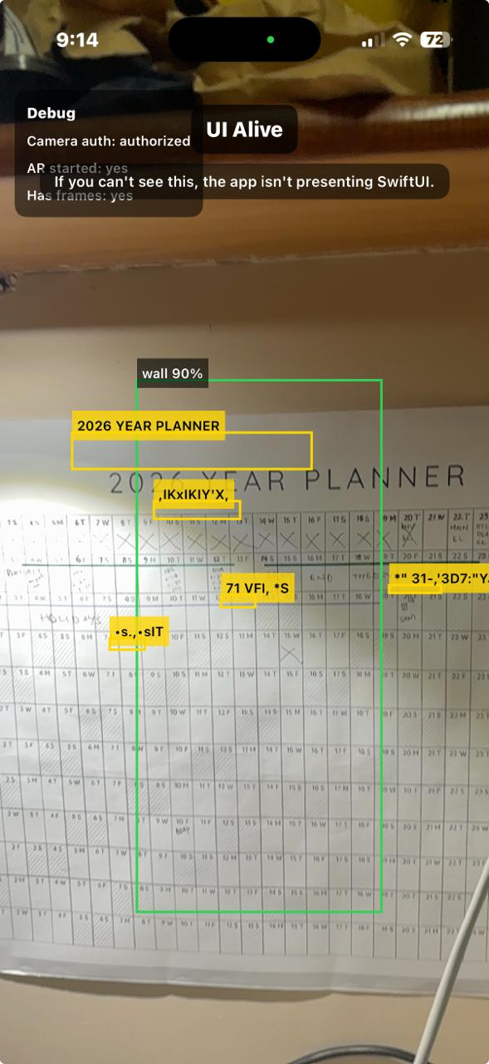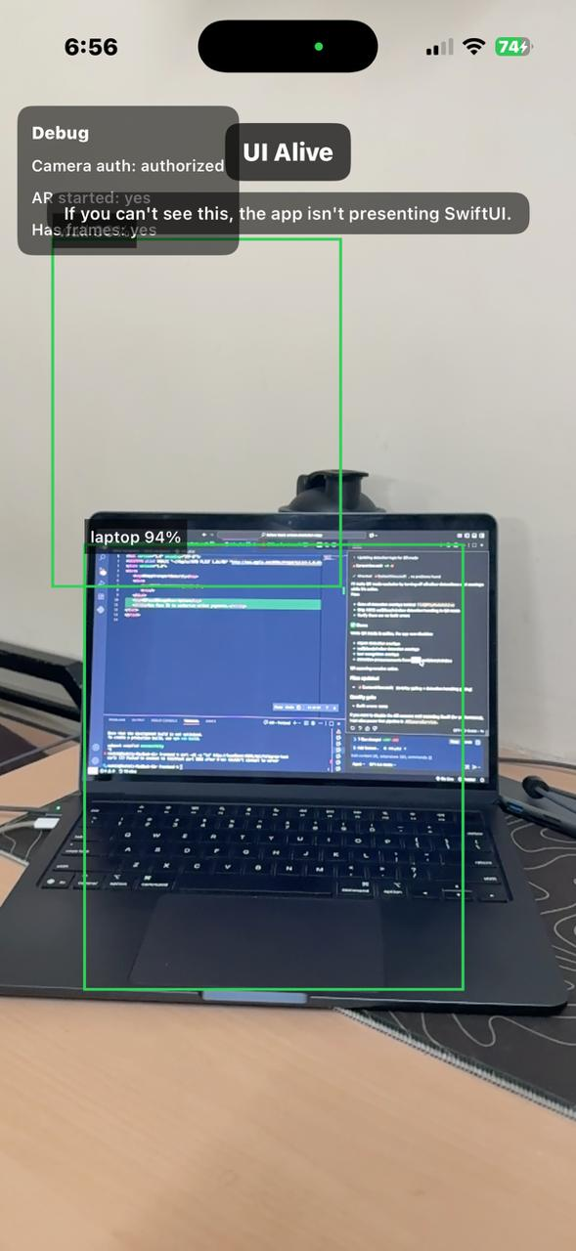
Text Recognition Object Detection

